Chapter 1
概念（列表）
对比性的要关注
①Job/CPU schedule
JOB schedule:choose a job among several ones ready to be brought into memory
CPU schedule:choose a job among several ones ready to run(into cpu)
②Process virtual system
③Symmetric multiprocessing(SMP)/ Asymmetric multiprocessing
Symmetric:Each processor runs identical copy of the operating system.
Asymmetric:Each processor is assigned a specific task;master processor schedules and allocated work to slave processors
④ Desktop System（个人计算机系统）
User convenience and responsiveness
Parallel Systems【多处理器系统（并行系统或紧耦合系统）】
More than one CPU , share memory and clock ,communicate through shared memory. Advantages:increased throughput,economical,increased reliability.
Distributed Systems（分布式系统）
Distribute the computation among several physical processors, own local memory,communicate through communication lines.
Advantages:resources sharing ,computation speed up, reliability ,communication.
Requires network,maybe c-s structure
Clustered Systems（集群系统）
Share storage,provide high reliability
Asymmetric clustering:one runs while others standby
Symmetric clustering:all runs application
Real-Time Systems（实时系统（软/硬））
Hard real-time:secondary storage limited
Soft real-time:priority
Handheld Systems（手持系统）
Cell phone,limited memory,slow process,small screen
⑤Interrupt（中断）
- transfers control to the interrupt service through interrupt vector
- save the address of interrupted instruction
- disabled interrupt occur when a interrupt is processing
⑥Cache
Faster storage
⑦Process（进程）
Process:A program loaded into memory and executing is commonly referred to as a process
A program in execution
⑧System calls
Provide the interface between a running program and operating system
⑨单核/微核
虚拟机（知道）

Chapter 2
一、
①进程
进程与线程的区别和联系
进程状态（图）
New : the process is being created
Running : instructions are being executed
Waiting : the process is waiting for some event to occur
Ready : the process is waiting to be assigned to a process
Terminated : the process has finished execution
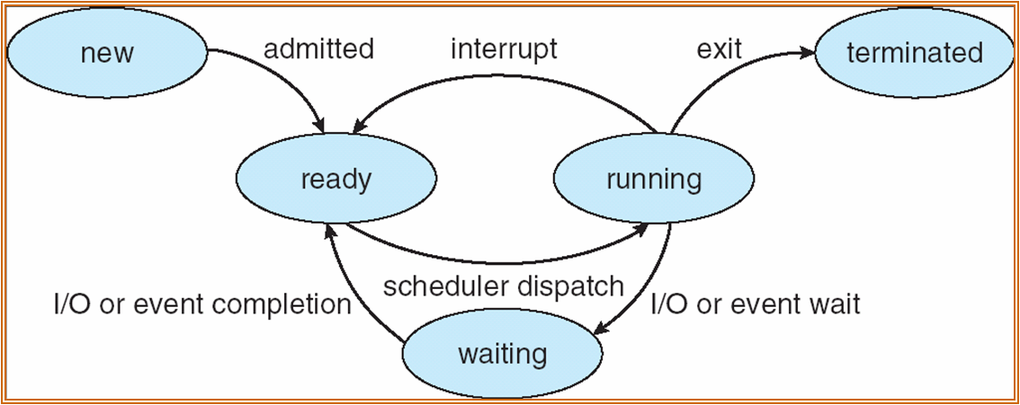

②PCB(process control block)
进程调度
PCB is a data structure in the operating system kernel containing the information needed to manage a particular process
Information associated with each process:
-process state
-program counter
-cpu register
-cpu scheduling information
-memory-management information
-accounting information
-i/o state information
③Longterm(job)/Shortterm(CPU) schedule
JOB queue: set of all processes in the system
Ready queue: set of all processes in main memory , ready and waiting to execution
Device queue: set of processes waiting for i/o device

Longterm schedule: selects which process should be bought into ready queue
Shortterm schedule: select which process should be executed next and allocates cpu

The longterm schedule controls the degree of multiprogramming
Context Switch(上下文切换)（特征）
cpu switch to another process ,the system saved the state of the old process and loaded the saved state for the new process
context switch time is overhead(not useful)
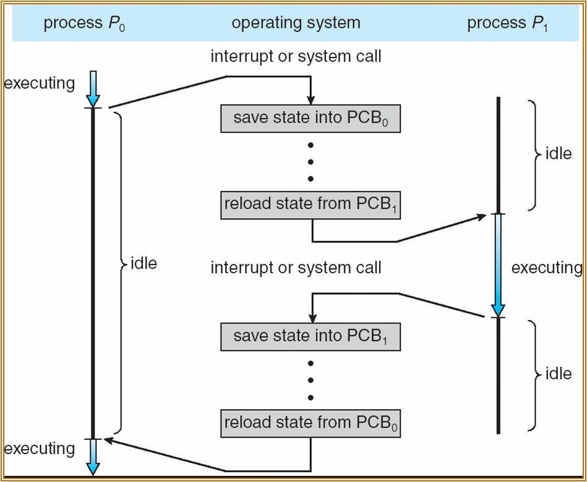
二、Interprocess Communication (IPC)（进程间通信）
Mechanism for process to communicate and to synchronize their actions
Message system: processes communicate with each other without resorting to shared variables
Synchronization同步/异步 （不好考-）
Blocking – synchronous
Non-blocking - asynchronous
进程/线程 （区别，好处）
进程是可以拥有资源的独立单元，同时又是可独立调度和分派的基本单元
线程是在轻量级进程，他与同一进程下的其他线程共享代码段、数据段和其他操作系统资源
Benefit : responsiveness, sharing, economy, multi processors architectures

用户/内核 线程的区别（邮箱）
User threads are whose management done by user-level threads library
Kernel threads are supported by the kernel

三、CPU调度
CPU scheduler selects a process from processes in memory that are ready to execute, and allocates the CPU to it
图
抢占/非抢占
Nonpreemptive: switches from running to waiting state, from running to ready state, from waiting to ready, terminates
Others is preemptive
Dispatcher（次要概念）
Dispatcher module gives control of CPU to the process selected by the short-term scheduler ; this involves: switching context, switching to user mode, jumping to the proper location in the user program to restart that program
Dispatch latency : time it takes for the dispatcher to stop one process and start another running
Scheduling Criteria计算
CPU utilization : keep the CPU as busy as possible
Throughput: the number of processes that complete their execution per time unit
Turnaround time: amount of time to execute a particular process
Waiting time : amount of time a process has been waiting in the ready queue
Response time : amount of time it takes from when a request was submitted until the first response is produced, not output( for time sharing environment)
Waiting time/ turnaround time/average time
Gantt chart

FCFS is the simplest CPU scheduling algorithm, with which, the process that request the CPU first is allocated the first. Implementation of the FCFS policy is easily managed with FIFO queue

SJF associate with each processes the length of its next CPU burst,(smallest next CPU burst)

Priority scheduling : a priority number is associated with each process, the CPU is allocated to the process with the highest priority(smallest == highest)
注意几种算法的缩写
SJF平均等待时间最短
一般：优先数越小优先级越高（注意审题）
饥饿：解决方法
Priority ++
RR(round robin): each process gets a small unit of CPU time, usually 10-100ms
多级反馈（Multilevel Feedback Queue）
Multilevel queue : ready queue is partitioned into separate queues, each queue has its own scheduling algorithm
Scheduling must be done between queues(fixed priority or time slice)
Multilevel feedback queue: allow process to move between queues. Each queue has different priority. Prevent starvation
四、进程同步
临界区（代码段）
Critical section : a code segment ,which processes share data
Ensure that when one process is executing in its critical section, no other process is allow to execute in its critical section
Solution : mutual exclusion, progress, bounded waiting
剩余区，进入区，退出区（解决临界区3条）
just like jdbc connect(entry section) dosth(critical section) close(exit section) deal with data(reminder section)
信号量（编程，必考）（wait：减； signal：加）
生产者/消费者 读者/写者
Monitor（管程）（简答）
A monitor is an object intended to be used safely by more than one thread

五、Deadlock（死锁）
Deadlock: Two or more processes are waiting indefinitely for an event that can be caused by one only of the waiting process
Starvation : indefinite blocking. A process may never be removed from the semaphore queue in which it is suspended.
Deadlocks headling:
Prevention, Avoidance, Detection, Recover from deadlock
产生原因
Mutual exclusion, hold and wait, no preemption, circular waits
特点（4条）
银行家算法/死锁检测（二者选其一）
资源分配图
处理方法（预防、避免、恢复）
Chapter 3
逻辑地址/物理地址
Logical address: generated by the CPU
Physical address: address seen by the memory unit
Logical and physical address are the same in compile-time and load-time schema, but different in execution-time schema

MMU（Memory-Management Unit ）
MMU: is a hardware device that maps virtual to physical address
So the user program deals with logical addresses; it never sees the real physical addresses; the memory mapping hardware converts logical address into physical addresses
Dynamic linking （动态链接）
Dynamic loading: a routine is not loaded until it is called
Dynamic linking: linking postponed until execution time
Stub: it is a small piece of code, used to locate the appropriate memory-resident library routine

Overlays
Overlays: in order to enable a process to be larger than the amount of memory allocated to it; so it keep in memory only those instructions and data are needed in any given time
Swapping（进程）
A process can be swapped temporarily out of memory to a backing store and the brought back into memory for continued execution
连续分配
Each process is contained in a single contiguous section of memory
Hole
A block of available memory
First/best/worst fit
First-fit and best-fit better than worst-fit in terms of speed and storage utilization
内外部碎片（结合别的知识点考察）
External fragmentation: total memory space exists to satisfy a request, but it is not contiguous.
Internal fragmentation: allocated memory may slightly larger than requested memory; this size difference is memory internal to a partition, but not being used
Paging
Paging is a memory-management scheme that permits the physical address space of a process to be noncontiguous
frames: Divide physical memory into fixed-sized blocks
pages: divide logical memory into the same size
page number: used as an index into a page table which contains base address of each page in physical memory
page offset: combined with base address to define the physical memory address that sent to the memory unit
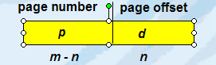
Paging itself is form of dynamic relocation only caused internal fragmentation
PTBR(page-table base register): points to the page table
PTLR(page-table length register): indicates size of the page table
TLB
Translation look-aside buffer is a CPU cache that memory management hardware used to improve virtual address translate speed
TLB MISS: if the page number is not in the TLB(known as a TLB MISS)
EAT
Effective memory-access time: the percentage of times that a particular page number is found in the TLB is called the hit ratio

有效/无效性
Associating protection bit with each frame
Page table structure (画页表)
Hierarchical page table: break up the logical address space into multiple page table
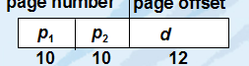
Hashed page table:
Hashed function->linked list->frames and offset
Inverting page table:
共享页（理解）
Share code
Segment（段）
Segmentation is memory-management scheme that supports this user view of memory
Segment is a logical unit
Segmentation architecture: <segment-number , offset>
segment table: maps two-dimensional logic addresses to one-dimensional physical address
STBR and STLR
Virtual memory（虚拟内存）
Separation of user logical memory from physical memory, which implemented via demand paging or demand segmentation
Virtual memory: a technique that allows the execution of a job that may not be completely in memory.

Demand paging:
Bring a page into memory only when it is needed;
Use valid-invalid bit to determine the page is in memory or in disk;

页错误
If there is ever a reference to a page, first reference will trap to OS
Steps:
- OS looks at another table to decide
- get empty frame
- swap page into the frame
- reset tables, and validation bit = 1
- restart instruction

If there is no empty frame, page replacement will happen: find some page in memory, but not really in use, swap it out
Copy-on-write
Allows both parent and child processes to initially share the same pages in memory, and only when modified pages are copied
Memory-mapped files
Allow several processes to map the same file allowing the pages in memory to be shared
页置换（算法）（计算）
Page replacement: prevent over-allocation of memory by modifying page-fault service routine to include page replacement.
Steps:
- find the location of the desired page on disk
- first find a free frame, if there is no free frame, use a page replacement algorithm to select a victim frame
- read the desired page into the newly free frame. Update the page and frame tables
- restart the process

page replacement algorithm:
FIFO: first in first out
LRU: least recently use
MFU: max frequency use
LFU: min frequency use
Optimal algorithm

脏位
Dirty bit: mark the page is modified,
Thrashing（颠簸）（简答，名词解释）
a process is busy swapping pages in and out
high paging activity is called thrashing. A process is thrashing if is spending more time paging than executing
TLB Reach = TLB size * page size
文件系统
文件概念
a file is a named collection of related information that recorded on the secondary storage
目录结构（灵活的）
Many different types of information may be stored in a file, according to which a file has a certain defined structure
File attributes: name , identifier, type, location , size, protection
File operation: create, write, read, file seek, delete, truncate

Several pieces of data are needed to manage open files:
File pointer, file-open count, disk location of the file, access rights

Open file locking: provide by some OS and file system

Access method: sequential access, direct access, index

Directory structure: a collection of nodes containing information about all files

Common directory structure:
Single-level
Two-level
Tree-structure
Acycle-graph directories
General graph directory
无圈图，为什么不能有圈
Mount挂载（过程，为什么挂载）
A file system must be mounted before it can be accessed
Mount point: where the file system is mounted
文件系统实现
FCB
FCB(file control block): contains information about the file
打开、关闭文件过程
create a file steps:
- allocates a new FCB
- reads the appropriate directory into memory
- updates it with the new file name and FCB
- write it back to the disk

open a file steps:
- open call passes a file name to the file system
- when a file is opened, the directory structure is searched for the given file name
- open call returns a pointer to the appropriate entry in the per-process file-system table

close a file steps:
- when a process closes the file, the per-process table entry is removed, the system-wide entry’s open count is decremented
- when all user close the file , the updated file information is copied back to the disk-based directory structure, and system-wide open-table entry is removed
虚拟文件系统（不定项）
Virtual file systems provide an object-oriented way of implementing file systems
Can use the same APIs
FAT/Unix分别是那种分配方式
Liner list of file name with a pointer to the data blocks
Hash table: liner list with hash data structure
磁盘分配方式几种（链式/线式/索引）
Allocation methods:
contiguous allocation:
each file occupies a set of contiguous blocks on the disk, simple, random access, wasteful of space, file can not grow

linked allocation:
each file is a linked list of disk blocks, simple, free-space management system, no random access

indexed allocation:
bring all pointers together into the index block, need index table, random access, dynamic access without external fragmentation, but have overhead of index block
Chapter 4 I/O系统
驱动（目的，块/字符设备）
To encapsulate the details and oddities of different devices, the kernel of operating system is structured to use driver modules

Device drives present a uniform devices-access interface to the I/O subsystem

I/O device : port, bus, controller

Device have addresses, used by: direct I/O instructions, memory-mapped I/O
Application I/O interface: I/O system calls encapsulate device behaviors in generic class

Block devices include disk driver
Commands include read, write, seek,
Raw I/O or file-system access
Memory-mapped file access possible

Character devices include keyboards, mice, serial ports
Commands include get, put
Libraries layered on top allow line editing

Network interface use socket

Clocks and timers
Provide current time, elapsed time, timer
If programmable interval timer used for timings, periodic interrupt

Blocking I/O: process suspended until I/O complete
Nonblocking I/O: I/O calls returns as much as available
内核I/O子系统
Kernel I/O subsystem: some I/O request ordering via per-device queue, some OSs try fairness
Buffer
Store data in memory while transferring between devices
Caching
Fast memory holding copy of data
Spooling
Spool is a buffer that holds output for a device
Hold output for a device
错误处理
OS can recover from disk read, device, unavailable, transient write failures
Most return an error number or code when I/O request fails
System error logs hold problem reports
如何提高I/O性能
I/O request to hardware operation:
- determine device holding file
- translate name to device representation
- physically read data from disk into buffer
- make data available to requesting process
- return control to process
Mass-store
RAID(0,1,5)

